North Lincolnshire Council
Daily Event Analysis
7th January 2011

Overview
The East Common Lane TEOM measured a daily mean PM₁₀ concentration of 51µg/m³ on Friday 7th January 2011 exceeding the allowed 50µg/m³ as a daily mean. The graph below shows the fluctuation in concentration through the day at East Common Lane and nearby sites Amvale and Redbourn Club.

A check of the data has revealed elevated concentrations of PM₁₀ between 03:00 and 04:00 at Amvale. During this period the Amvale Osiris measured a mean concentration of 141µg/m³, the East Common Lane TEOM 27µg/m³ and the Redbourn Club TEOM 24µg/m³. It should be noted however that the Amvale Osiris did not exceed the 50µg/m³ for the day.

It was also observed later in the morning elevated concentrations of PM₁₀ between 06:45 and 09:45 at East Common Lane. During this period the East Common Lane TEOM measured a mean concentration of 130µg/m³, the Amvale Osiris 63µg/m³ and the Redbourn Club TEOM 81µg/m³.
Met Conditions

Primarily Easterly winds were recorded throughout the day. The wind within the 1 hour period of focus at Amvale ranged between 144° and 233°. Light rain was measured throughout the day.

Episode Wind Range
Amvale 03:00-04:00
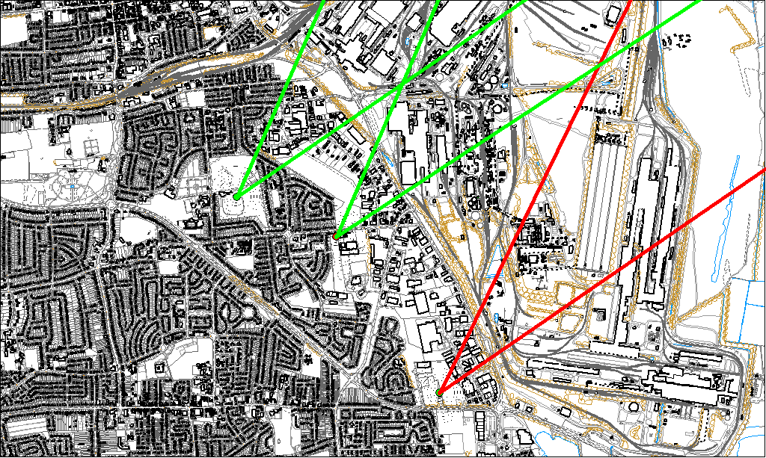
Potential Sources
The likely areas include;

- Sinter Plant
- Ore beds
- Civil and Marine

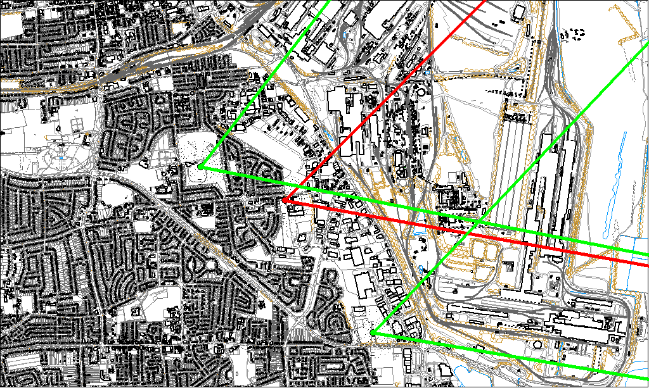
Episode Wind Range
East Common Lane 06:45-09:45

During the 3 hour period of focus at East Common Lane the wind ranged between 44° and 100°. Wind speed averaged 2.6 m/s for the day.

Potential Sources

The likely areas include;

- Sinter Plant
- Ore beds
- Intermediate Site
- Blast Furnaces

